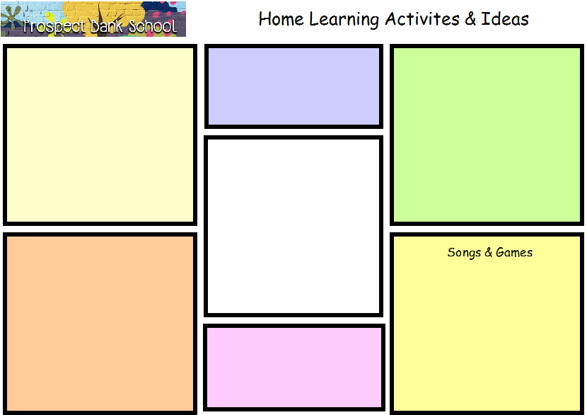
Take your hands or a toy on a Bear Hunt. You could set up a bear hunt in your garden.
Bear Biscuit
Learning adventures with PB Bear
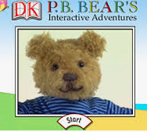
http://pbbear.lgfl.org.uk/

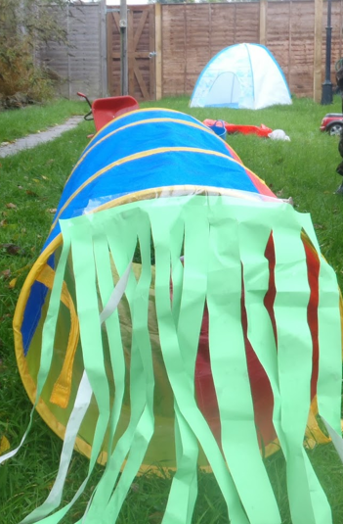
http://verymessymummy.blogspot.com/2013/10/were-going-on-bear-hunt.html?m=1

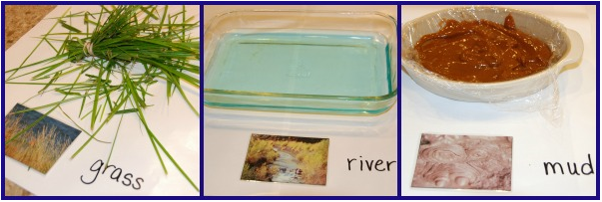
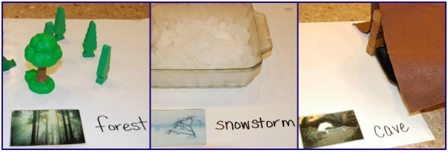
Bear Hunt
Use recycling to make binoculars for your bear hunt.
Binoculars
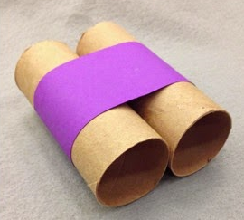
Teddy counting https://www.topmarks.co.uk/learning-to-count/teddy-numbers https://garyhall.org.uk/gordons/swf/Teddy_numbers_v2.swf Mr Teddy tells the time https://mathsframe.co.uk/en/resources/resource/116/telling-the-time Ten In The Bed https://www.youtube.com/watch?v=TdDypyS_5zE

Maths activities
http://www.trampoliningbear.com/biscuits.php

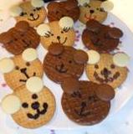
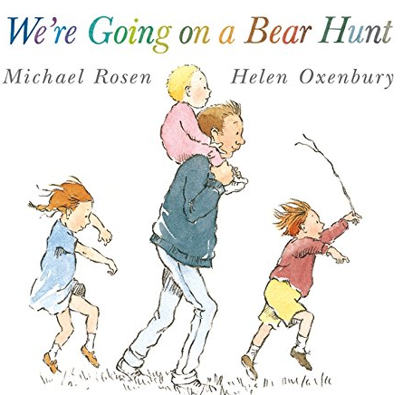
We’re Going on a Bear Hunt https://www.youtube.com/watch?v=0gyI6ykDwds We're Going on a Bear Hunt | Popular Song https://www.youtube.com/watch?v=5_ShP3fiEhU We're Going on a Bear Hunt | Kids Yoga https://www.youtube.com/watch?v=KAT5NiWHFIU Pairs game http://www.trampoliningbear.com/pairs.php

https://www.youtube.com/watch?v=Waoa3iG3bZ4

