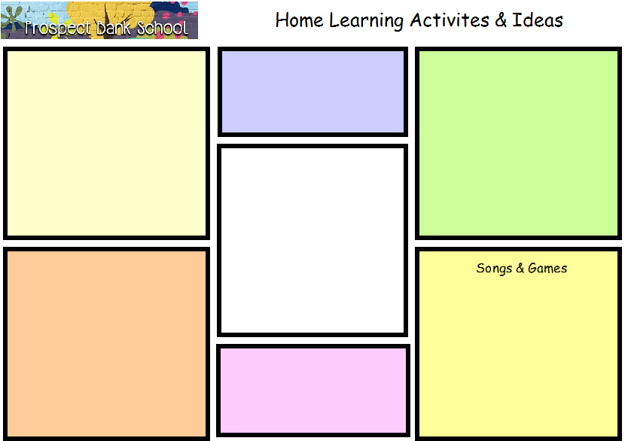
You need 1/4 cup baby oil for every 2 cups of flour. Mix together and keep in a tight container.
Date Chart www.ictgames.com/mobilepage/dateChart Tell the time https://uk.ixl.com/math/year-1/match-analogue-clocks-and-times Day and Night Song https://www.youtube.com/watch?v=TKvFgEwa0NU Mr Sun https://www.youtube.com/watch?v=TKvFgEwa0NU The Moon Song https://www.youtube.com/watch?v=xuZ3M7UghIM

Moon Sand
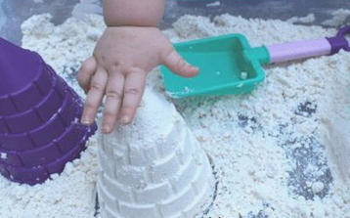

https://uk.ixl.com/ela/reception/choose-the-words-that-have-a-given-ending https://uk.ixl.com/ela/reception/choose-the-picture-that-rhymes-with-the-word

Lets Rhyme
Sunny Pancake

What melts in the sun?
https://www.pinterest.co.uk/pin/430445676888143373/

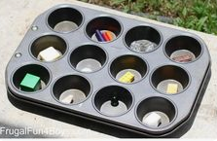
Day and Night Craft
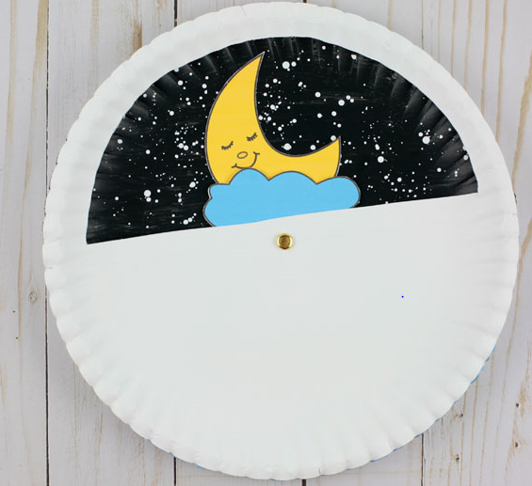
https://www.pinterest.co.uk/pin/430445676888141648/

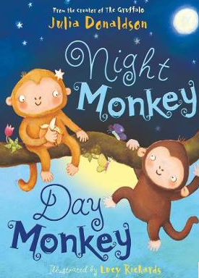
https://www.youtube.com/watch?v=ICxLOO9pua0

