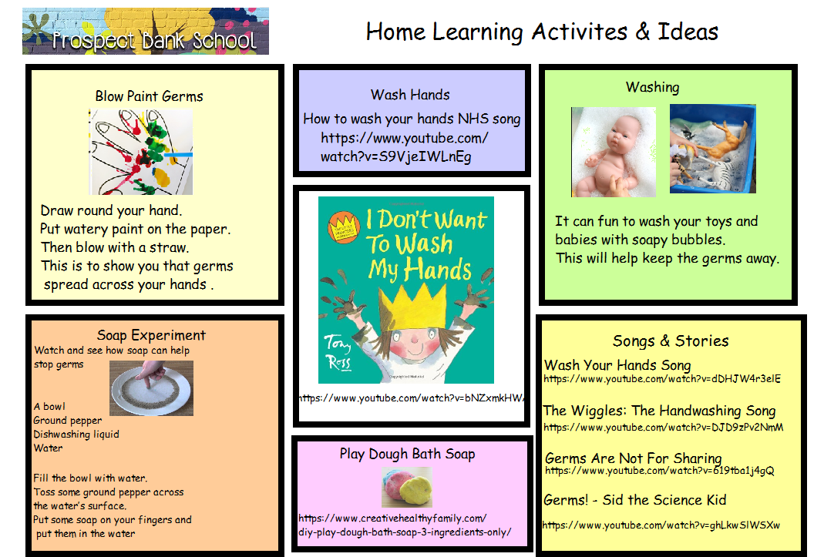
https://www.youtube.com/watch?v=bNZxmkHWA2Y

https://www.creativehealthyfamily.com/diy-play-dough-bath-soap-3-ingredients-only/

Wash Your Hands Song https://www.youtube.com/watch?v=dDHJW4r3elE
The Wiggles: The Handwashing Song https://www.youtube.com/watch?v=DJD9zPv2NmM
Germs Are Not For Sharing https://www.youtube.com/watch?v=619tba1j4gQ
Germs! - Sid the Science Kid https://www.youtube.com/watch?v=ghLkwSlWSXw

How to wash your hands NHS song
https://www.youtube.com/watch?v=S9VjeIWLnEg

